DATA SCIENCE WITH PYTHON
Integrative Capstone Project and Evaluation
From censored CDC mortality data to profiles and one-month forecasts
━━━━━━━━━━━━━━━━━━━━━━━━━━━━━━━━━━━━━━━━━━━━━━━
WEEK | 6
DATE | 18 August 2026
DATASET | Provisional COVID-19 Deaths by Sex and Age

Student name | Mandal Sahil Naushad
Institution | YuvaIntern
Public-use aggregate mortality data • Reproducible Python workflow

Report map
The document follows the required submission structure. Major sections are separated visually and use Word heading styles for navigation.
- 1. Title Page
- 2. Introduction
- 3. Dataset Overview
- 4. Methodology
- 5. Python Code Sections
- 6. Results and Findings
- 7. Visualizations (described in text)
- 8. Challenges and How They Were Handled
- 9. Discussion
- 10. Conclusion
- 11. References

2. Introduction
This capstone combines the six-week workflow into one reproducible public-health data science pipeline. The project acquires and audits the CDC Provisional COVID-19 Deaths by Sex and Age extract, performs grain-safe exploratory analysis, clusters jurisdictions by mortality profile, evaluates a conventional supervised model honestly, and builds a compact residual neural network that improves a strong operational baseline.
The project opportunity is twofold: describe how burden differs by time, age, sex, respiratory overlap, and jurisdiction; then test whether recent history can support one-month-ahead jurisdiction forecasts. The dataset was selected because its privacy suppression, overlapping aggregates, right-skewed counts, and nonstationary waves require connected decisions across the full pipeline rather than isolated code demonstrations.
Capstone result. Cleaning preserved all 137,700 records without zero-filling suppressed cells; EDA identified a January 2021 peak and 75.76% age-65+ share; four modest clusters described jurisdiction profiles; the Week 4 booster failed against persistence; a baseline-anchored residual network improved test MAE by 29.94%.

3. Dataset Overview
The CDC/NCHS CSV contains 137,700 rows, 16 raw columns, 54 geography labels, three sex categories, 17 age groups, and monthly/yearly/cumulative grains. It covers 1 January 2020 through 23 September 2023 and was published as of 27 September 2023. The publisher states that the table is no longer updated; the capstone therefore demonstrates method on a historical extract.
Quality characteristic | Observed evidence | Pipeline response
Privacy suppression | 39,430 COVID; 44,864 pneumonia blanks; all on footnoted rows | Retain NaN; add measure flags; midpoint only for lag predictors.
Mixed grains | 123,930 monthly; 11,016 yearly; 2,754 total | Require explicit Group filter.
Overlapping age schemes | 17 groups include incompatible bands | Use 11 mutually exclusive bands for sums.
Partial endpoint | 5,508 Sep/2023 rows | Flag; exclude from complete-period models.
Right-skewed counts | CA, FL, TX exceed IQR cutoff | Keep valid records; use shares/log residuals.
Geographic overlap | US total and NYC nested in NY | Exclude both from 52-unit modeling matrix.
Table 1. Source characteristics and the connected response across project phases.
The clean master table has 25 columns after type conversion, six suppression flags, a row suppression flag, a partial-period marker, and a safe COVID share. It retains all source rows so later analytical slices can be rebuilt without returning to a modified raw file.

4. Methodology
This section condenses every phase from Weeks 1–5 in the order of a production data science pipeline, while retaining the rationale behind each decision.

Phase 1 — Acquisition and reproducibility
The attached file was matched to CDC Socrata identifier 9bhg-hcku by title, schema, publisher, and update date. The raw input is treated as immutable. Paths, exact source URL, software libraries, deterministic seeds, and fixed split dates are documented so the analysis can be rerun.

Phase 2 — Cleaning and preprocessing
All fields were first loaded as text. Dates use explicit MM/DD/YYYY parsing; commas are removed from six documented count fields; Year/Month use nullable integers. Suppressed 1–9 cells stay missing and receive measure-level flags. Domain assertions check duplicates, dates, nonnegativity, totals, and overlap logic. September 2023 and 2023 yearly records are marked partial.

Phase 3 — Exploratory analysis
National monthly trends use By Month/United States/All Sexes/All Ages. Age and sex comparisons use the 11-band exclusive scheme. Jurisdiction comparison uses 52 non-overlapping units and COVID-19 as a percentage of all deaths. Spearman correlation summarizes aligned complete-month mortality series without assuming normality.

Phase 4 — Unsupervised profiles
Seven percentages—COVID, pneumonia, overlap, influenza, age 65+, male share, and 2021 timing—are standardized. K-Means candidates k=2–8 are compared with inertia and silhouette; k=4 has the highest silhouette at 0.222. PCA and Ward linkage visualize the groups without replacing the seven-dimensional fit.

Phase 5 — Conventional supervised benchmark
The one-month regression uses three COVID lags, rolling mean, lagged total/pneumonia, seasonal encoding, time trend, and one-hot state. HistGradientBoosting is trained on log counts with chronological validation. The previous-month forecast is the baseline. On 2023, the booster is rejected because all four metrics are worse than persistence.

Phase 6 — Deep residual model
A compact 32→16 ReLU network predicts the log correction to the previous month. Zero output initialization preserves the baseline at start; dropout, L2, Huber loss, and early stopping address the small sample. The fit/validation/test windows are chronological, and an unregularized reference provides direct overfitting evidence.

Phase 7 — Evaluation and decision rules
Model selection uses future-block MAE, RMSE, R², WAPE, baseline comparison, and worst-case inspection. Descriptive results are checked against exact tables. No model is recommended because it is complex or has positive R²; it must improve the baseline and remain stable under rolling monitoring.

5. Python Code Sections

Code 1 — Acquire, parse, and preserve suppression
```python
from pathlib import Path
import matplotlib.pyplot as plt
import numpy as np
import pandas as pd
import seaborn as sns
from sklearn.cluster import KMeans
from sklearn.compose import ColumnTransformer
from sklearn.decomposition import PCA
from sklearn.ensemble import HistGradientBoostingRegressor
from sklearn.metrics import mean_absolute_error, mean_squared_error, r2_score, silhouette_score
from sklearn.preprocessing import OneHotEncoder, StandardScaler
import tensorflow as tf
raw = pd.read_csv("Provisional COVID-19 Deaths by Sex and Age.csv",
dtype=str, low_memory=False)
df = raw.rename(columns={
"Data As Of": "data_as_of", "Start Date": "start_date", "End Date": "end_date",
"Group": "group", "Year": "year", "Month": "month", "State": "state",
"Sex": "sex", "Age Group": "age_group", "COVID-19 Deaths": "covid_deaths",
"Total Deaths": "total_deaths", "Pneumonia Deaths": "pneumonia_deaths",
"Pneumonia and COVID-19 Deaths": "pneumonia_covid_deaths",
"Influenza Deaths": "influenza_deaths",
"Pneumonia, Influenza, or COVID-19 Deaths": "pic_deaths", "Footnote": "footnote",
})
```
Code explanation and output interpretation
- The capstone begins from the actual attached filename and maps every source field used later to a consistent name.
- Loading as text prevents chunk-based mixed typing before count and date rules are applied.
- The raw shape is 137,700 × 16, providing a fixed acquisition checkpoint.

Code 2 — Enforce quality rules and partial-period metadata
```python
count_cols = ["covid_deaths", "total_deaths", "pneumonia_deaths",
"pneumonia_covid_deaths", "influenza_deaths", "pic_deaths"]
for col in ["data_as_of", "start_date", "end_date"]:
df[col] = pd.to_datetime(df[col], format="%m/%d/%Y", errors="raise")
for col in ["year", "month"]:
df[col] = pd.to_numeric(df[col], errors="coerce").astype("Int64")
for col in count_cols:
df[col] = pd.to_numeric(df[col].str.replace(",", regex=False), errors="coerce")
df[f"{col}_suppressed"] = df[col].isna() & df["footnote"].notna()
month_end = df["start_date"] + pd.offsets.MonthEnd(0)
year_end = pd.to_datetime(df["year"].astype("string") + "-12-31",
format="%Y-%m-%d", errors="coerce")
df["is_partial_period"] = (
(df["group"].eq("By Month") & (df["end_date"] < month_end)) |
(df["group"].eq("By Year") & (df["end_date"] < year_end))
)
assert not df.duplicated(["group", "year", "month", "state", "sex", "age_group"]).any()
assert not (df["covid_deaths"] > df["total_deaths"]).any()
```
Code explanation and output interpretation
- Suppression remains explicit rather than being changed to zero, preserving the CDC's confidentiality interval.
- The partial-period rule identifies 5,508 rows and is reused by EDA and modeling.
- Executable grain and domain assertions protect every downstream result from silent structural errors.

Code 3 — Produce the national EDA slices
```python
exclusive_age = [
"Under 1 year", "1-4 years", "5-14 years", "15-24 years", "25-34 years",
"35-44 years", "45-54 years", "55-64 years", "65-74 years",
"75-84 years", "85 years and over",
]
monthly_us = df.query(
"group == 'By Month' and state == 'United States' "
"and sex == 'All Sexes' and age_group == 'All Ages'"
)
complete_us = monthly_us.loc[~monthly_us["is_partial_period"]]
age_us = df.query(
"group == 'By Total' and state == 'United States' and sex == 'All Sexes'"
).loc[lambda x: x["age_group"].isin(exclusive_age)]
peak = complete_us.loc[complete_us["covid_deaths"].idxmax()]
age65 = age_us.loc[age_us["age_group"].isin(
["65-74 years", "75-84 years", "85 years and over"]
), "covid_deaths"].sum()
print(peak["start_date"], peak["covid_deaths"])
print(100 * age65 / age_us["covid_deaths"].sum())
```
Code explanation and output interpretation
- The filters lock one grain and avoid adding aggregate rows to components.
- The national peak is January 2021 with 105,565 deaths; ages 65+ account for 75.76% of cumulative deaths.
- These exact checkpoints anchor the visualization narrative and later recommendations.

Code 4 — Select and fit the four-profile clustering
```python
# features is the 52 × 7 percentage matrix documented in Week 3.
X_cluster = StandardScaler().fit_transform(features)
selection = []
for k in range(2, 9):
candidate = KMeans(n_clusters=k, n_init=50, random_state=42)
labels = candidate.fit_predict(X_cluster)
selection.append((k, candidate.inertia_, silhouette_score(X_cluster, labels)))
cluster_model = KMeans(n_clusters=4, n_init=100, random_state=42)
cluster_labels = cluster_model.fit_predict(X_cluster)
pca_points = PCA(n_components=2).fit_transform(X_cluster)
print(selection)
```
Code explanation and output interpretation
- The feature matrix uses shares rather than raw counts, so distance represents mortality profile instead of population size.
- Four clusters are selected because k=4 has the highest tested silhouette (0.222), while the close scores are retained as a limitation.
- PCA is a display tool; assignments use all seven standardized features.

Code 5 — Build leak-free one-month forecasting features
```python
panel = df.query(
"group == 'By Month' and sex == 'All Sexes' and age_group == 'All Ages'"
).loc[lambda x: ~x["state"].isin(["United States", "New York City"])
& ~x["is_partial_period"]].sort_values(["state", "start_date"])
for col in ["covid_deaths", "total_deaths", "pneumonia_deaths"]:
panel[f"{col}_for_lag"] = panel[col].fillna(5.0)
g = panel.groupby("state")
for lag in [1, 2, 3]:
panel[f"lag{lag}_covid"] = g["covid_deaths_for_lag"].shift(lag)
panel["rolling3_covid"] = g["covid_deaths_for_lag"].transform(
lambda s: s.shift(1).rolling(3).mean()
)
panel["lag1_total"] = g["total_deaths_for_lag"].shift(1)
panel["lag1_pneumonia"] = g["pneumonia_deaths_for_lag"].shift(1)
```
Code explanation and output interpretation
- All count predictors are shifted within state, ensuring the current target is unavailable at forecast time.
- A midpoint is used only for censored lag inputs; suppressed target rows are excluded from metric calculations.
- The resulting 2,069-row panel supports identical chronological comparisons across conventional and neural models.

Code 6 — Define the residual neural correction
```python
regularizer = tf.keras.regularizers.l2(1e-3)
network = tf.keras.Sequential([
tf.keras.layers.Input(shape=(61,)),
tf.keras.layers.Dense(32, activation="relu", kernel_regularizer=regularizer),
tf.keras.layers.Dropout(0.20),
tf.keras.layers.Dense(16, activation="relu", kernel_regularizer=regularizer),
tf.keras.layers.Dropout(0.15),
tf.keras.layers.Dense(1, activation="linear",
kernel_initializer="zeros", bias_initializer="zeros"),
])
network.compile(optimizer=tf.keras.optimizers.Adam(1e-3),
loss=tf.keras.losses.Huber(delta=0.3))
# y = log1p(current deaths) - log1p(previous-month deaths)
# final forecast = expm1(log1p(previous month) + predicted correction)
```
Code explanation and output interpretation
- The 2,529-parameter network is deliberately compact for 1,381 fit rows.
- The zero-initialized linear output starts from the lag-1 forecast and permits signed corrections.
- Dropout, L2, Huber loss, and early stopping respond to the overfitting seen in the unregularized reference.

Code 7 — Apply a baseline-first model acceptance rule
```python
def score(actual, prediction):
return {
"MAE": mean_absolute_error(actual, prediction),
"RMSE": mean_squared_error(actual, prediction) ** 0.5,
"R2": r2_score(actual, prediction),
"WAPE_pct": 100 * np.abs(actual - prediction).sum() / actual.sum(),
}
baseline_score = score(y_test, lag1_prediction)
boosted_score = score(y_test, boosted_prediction)
neural_score = score(y_test, neural_prediction)
accepted = (
neural_score["MAE"] < baseline_score["MAE"]
and neural_score["RMSE"] < baseline_score["RMSE"]
and neural_score["WAPE_pct"] < baseline_score["WAPE_pct"]
)
print(baseline_score, boosted_score, neural_score, accepted)
```
Code explanation and output interpretation
- The same observed 2023 target rows are scored for every method, making the comparison fair.
- The booster fails the acceptance rule; the residual network passes with MAE 34.253, RMSE 59.621, R² 0.867, and WAPE 26.825%.
- Acceptance is conditional on this historical holdout; live deployment still requires intervals, drift monitoring, and current data.

6. Results and Findings
Pipeline phase | Result | Meaning
Cleaning | 137,700 rows retained; 0 key duplicates; 5,508 partial rows flagged | Representation improved without deleting valid events.
Suppression | COVID blanks 28.63%; pneumonia blanks 32.58% | Censoring is material and non-random.
National EDA | 1,146,774 COVID deaths; 9.32% of 12,303,399 total | Historical cumulative burden in source period.
Peak month | Jan 2021: 105,565; 28.25% of all deaths | Wave structure dominates averages.
Age | 65+: 868,831; 75.76% | Burden is concentrated among older adults.
Sex | Male/female 1.218; max ratio 1.75 at 45–54 | Midlife proportional gap is visible beyond oldest-age counts.
Clustering | k=4; silhouette 0.222; sizes 8/13/23/8 | Useful but soft profile segmentation.
Boosted test | MAE 69.259; R² 0.490; WAPE 54.239% | Worse than persistence; rejected.
Residual neural test | MAE 34.253; R² 0.867; WAPE 26.825% | 29.94% MAE improvement over persistence.
Table 2. Integrated capstone outcomes.
The strongest project finding is methodological: preserving the baseline within the architecture mattered more than increasing model complexity. The Week 4 tree model had a respectable positive R² but failed every comparison against persistence. The residual network improved because it learned a bounded correction around a credible starting point and stopped after early validation gains.
Descriptively, mortality burden is concentrated by age and wave but varies meaningfully in composition. Four clusters capture older-age concentration, male skew, pneumonia overlap, and year timing. Their modest separation means they are best used to choose peer comparisons and hypotheses, not to declare one group successful or unsuccessful.

7. Visualizations (described in text)
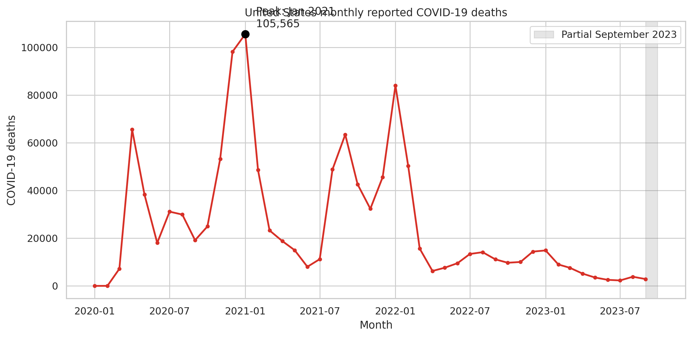
Figure 1. Complete-period national monthly COVID-19 trend with partial September 2023 shaded.
Technical reading: the x-axis is month and y-axis is COVID-19 deaths, with January 2021 annotated. Analytical reading: repeated waves and a large 2021 peak make random validation and simple averages unsafe. The partial-period shading shows how data-quality metadata changes interpretation.
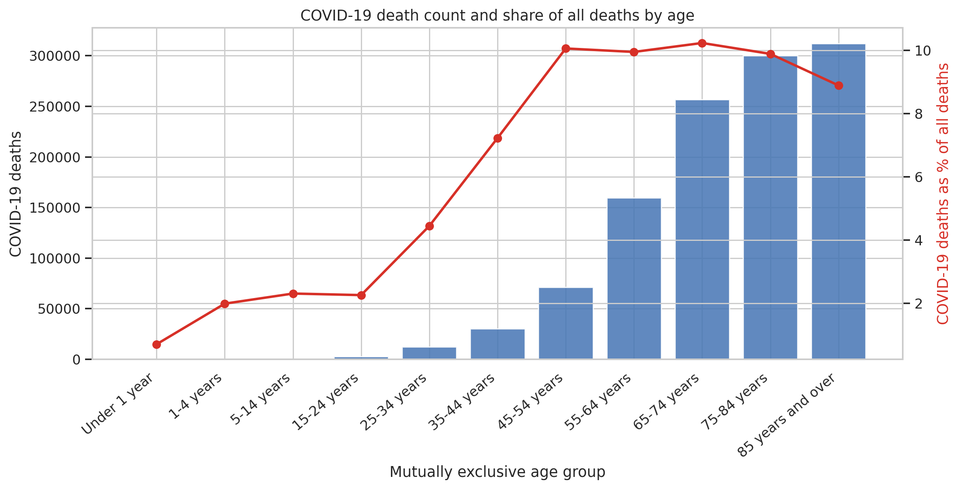
Figure 2. Cumulative count and within-age death-share across mutually exclusive age groups.
Technical reading: bars and a secondary-axis line represent count and percentage. Analytical reading: the oldest group has the largest count, while 65–74 has the highest COVID share of all deaths. Policy interpretation changes depending on which measure is used.
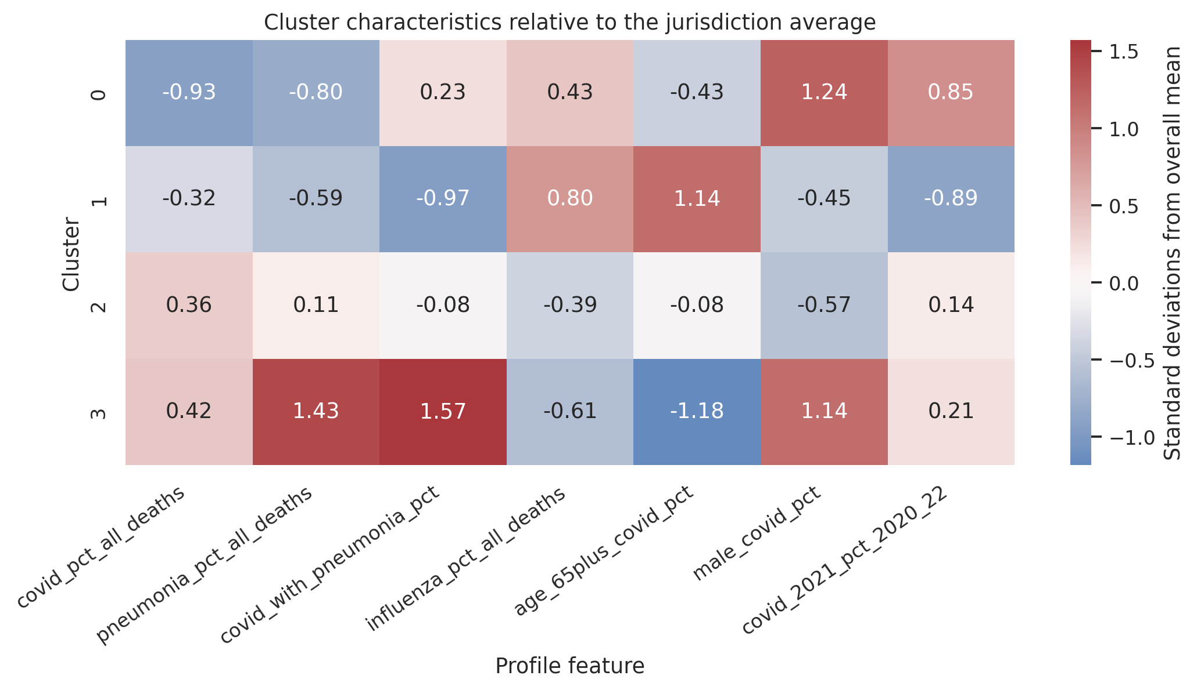
Figure 3. Standardized four-cluster centroid profiles across seven engineered percentages.
Technical reading: values are standard deviations from the 52-jurisdiction mean. Analytical reading: Cluster 1's older-age concentration and Cluster 3's pneumonia overlap/younger male profile are multivariate differences that a raw-count ranking would miss.
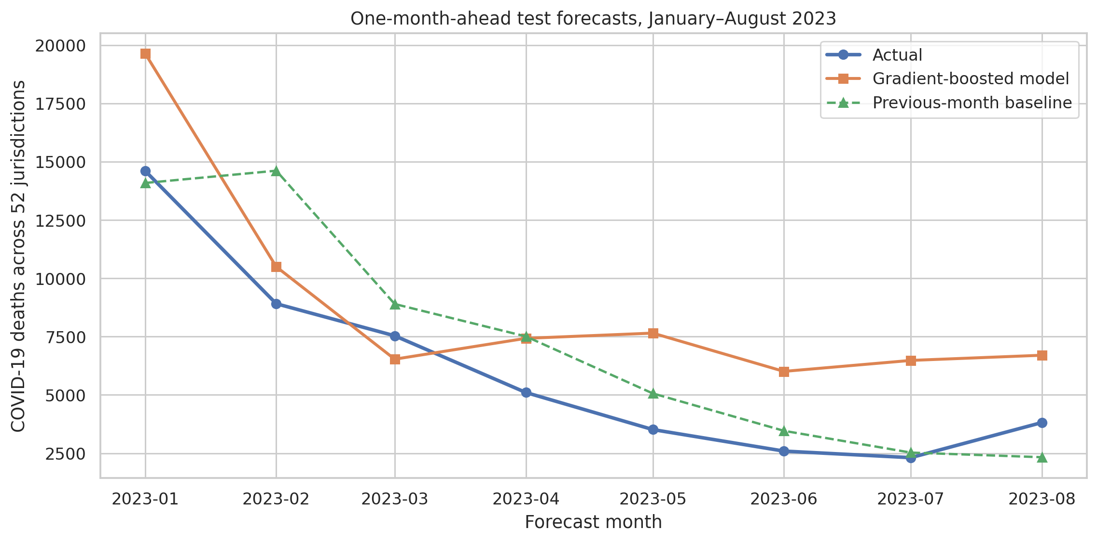
Figure 4. Week 4 boosted model versus persistence on the future holdout.
Technical reading: aggregated forecast lines use the same observed state-months. Analytical reading: the booster stays too high through decline, explaining why it loses despite positive R². This is the rejected benchmark that motivates residual design.
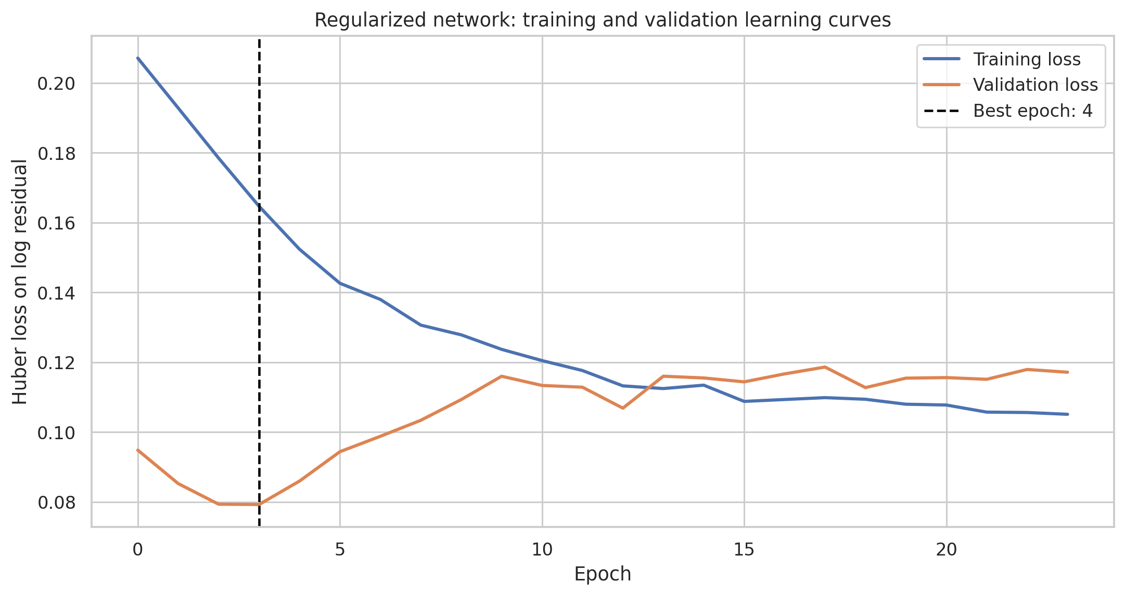
Figure 5. Residual neural-network learning curves with the best validation epoch marked.
Technical reading: Huber loss is plotted for fit and validation sets by epoch. Analytical reading: useful learning happens immediately and additional fitting risks memorization. Restoring epoch 4 is justified by observed validation behavior.
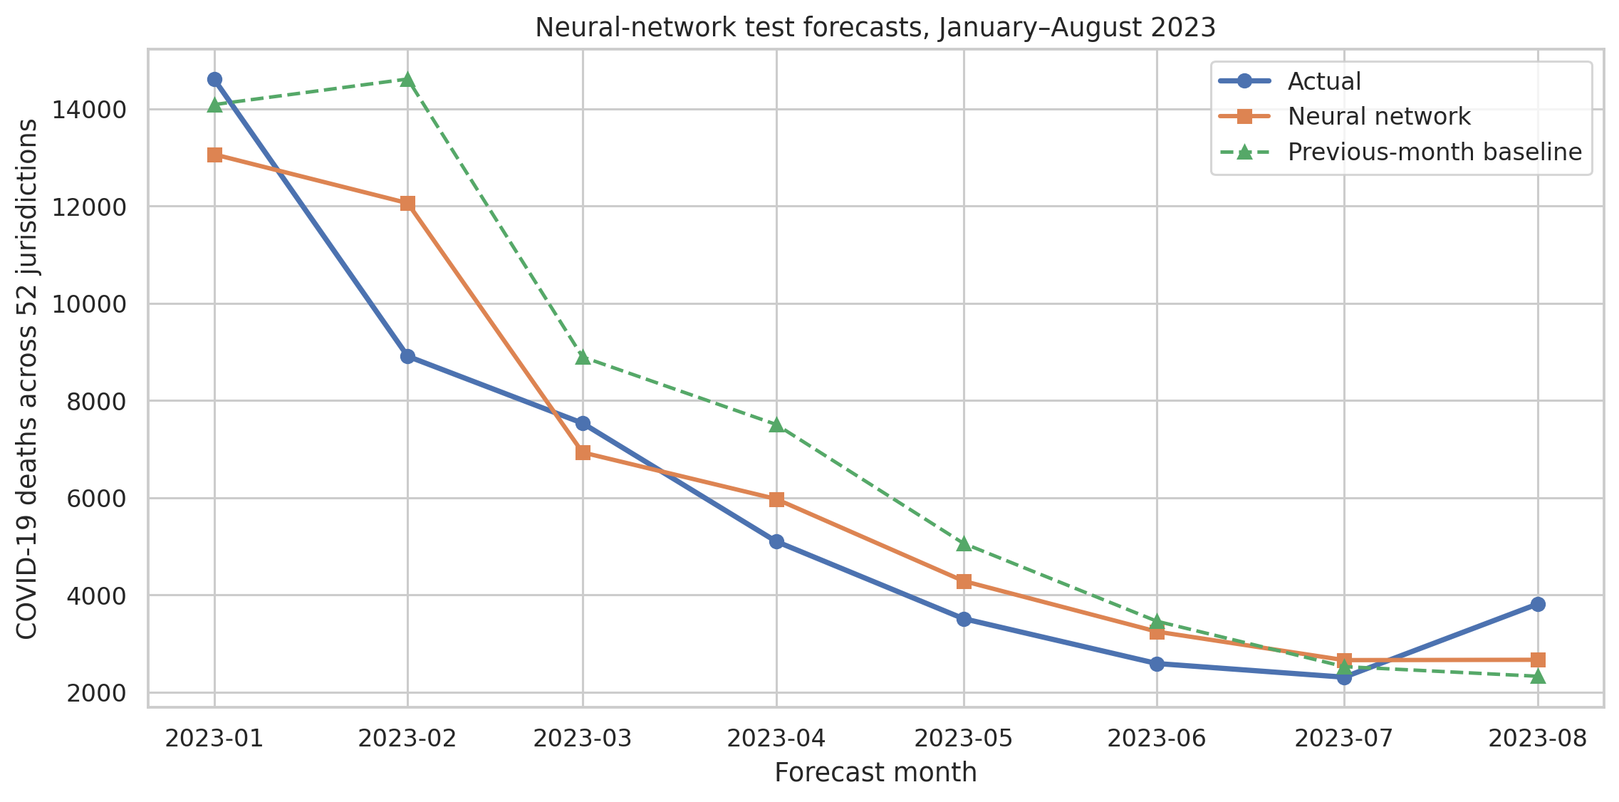
Figure 6. Residual neural forecast, persistence baseline, and actual 2023 holdout totals.
Technical reading: all lines aggregate identical scored rows. Analytical reading: learned corrections improve the broad decline while large January–February transition errors remain. The model should be a monitored challenger, not an unqualified replacement.

8. Challenges and How They Were Handled
Challenge | Resolution | Evidence
Censored small counts | Preserve NaN and flags; midpoint only for lag inputs | All missing count cells align with privacy-footnoted rows.
Double-counting risk | Explicit Group/Sex/Age filters and exclusive age bands | Exclusive bands reconcile to All Ages.
Valid extreme counts | Retain CA/FL/TX; use shares/log residuals | Zero domain violations despite IQR flags.
Weak cluster boundaries | Report silhouette and soft interpretation | Best 0.222; k=7 close at 0.220.
Temporal regime change | Expanding windows and future holdout | Boosted model reverses from early-fold wins to late losses.
Neural overfitting | Compact model, dropout, L2, Huber, early stopping | Unregularized validation loss 0.49378 vs train 0.01497.
Frozen data source | Limit claims to historical period; recommend CDC WONDER/current feeds | Publisher stopped updates after 27 Sep 2023.
Table 3. Project challenges, actions, and observed evidence.

9. Discussion
The pipeline demonstrates that cleaning decisions determine modeling validity. Suppression cannot be treated as zero, overlapping categories cannot be freely summed, and partial periods cannot be model targets. Each of those mistakes would improve apparent completeness while degrading truth. Retaining flags allows the same clean master table to serve descriptive and predictive tasks with different, explicit assumptions.
The models also show why evaluation must include a baseline and multiple metrics. The boosted model's R² 0.490 sounds useful until persistence reaches 0.732 with lower error. The residual network reaches 0.867 and reduces MAE, but worst errors above 300 deaths remain. For planning, a calibrated interval and state-specific error monitoring are at least as important as the point estimate.
No causal claim can be made from these aggregate occurrence counts. Cluster differences could reflect age structure, population, coding practice, epidemic timing, and healthcare access. The COVID share of all deaths is not a population rate. The source is frozen and provisional, so a current deployment must revalidate the schema and retrain on current data.

Concrete recommendations
- Adopt a data contract that requires Group, Sex, Age Group, geography, period completeness, and suppression status in every analytical extract. Reject aggregations that mix totals with components.
- Store suppressed counts as interval-censored values with lower=1 and upper=9 fields. Use lower/midpoint/upper sensitivity scenarios for summaries that depend on small cells; never silently zero-fill.
- Use the four clusters as peer groups for review: older-age interventions for Cluster 1; respiratory-overlap and working-age male analysis for Cluster 3; timing-focused comparisons for Cluster 0; broad burden benchmarking for Cluster 2.
- Run the residual network as a challenger beside the lag-1 baseline. Suspend its operational use if rolling two-month WAPE exceeds the baseline by more than 5 percentage points, and retrain only after diagnosing drift.
- Add prediction intervals through blocked conformal calibration or quantile loss before staffing decisions. Publish MAE, RMSE, WAPE, and worst-jurisdiction errors each month.
- Replace the frozen extract with current CDC WONDER or another maintained official feed, then add population by age, vaccination, hospitalization, and variant indicators. Those variables are needed for rates and may improve turning-point forecasts.
The 5-percentage-point monitoring threshold is a governance recommendation, not a value estimated from this dataset. It creates a clear fallback rule while the baseline remains available. A production owner should revise it based on the cost of over- and underforecasting.

10. Conclusion
The capstone delivered a complete data science pipeline on a difficult public-health table: 137,700 records were cleaned without erasing censoring; EDA quantified time, age, sex, geography, and respiratory association; standardized profile features produced four interpretable but modest clusters; chronological evaluation rejected a conventional boosted model; and a compact residual neural network improved future MAE to 34.253 and R² to 0.867.
The next stage is operational validation on a maintained CDC feed with population denominators, prediction intervals, and rolling drift checks. The recommended system keeps the previous-month forecast as a fallback and promotes the neural correction only while it continues to beat that baseline on future data.

11. References
- Centers for Disease Control and Prevention, National Center for Health Statistics. Provisional COVID-19 Deaths by Sex and Age. Dataset page: https://data.cdc.gov/National-Center-for-Health-Statistics/Provisional-COVID-19-Deaths-by-Sex-and-Age/9bhg-hcku
- CDC data download used for source verification: https://data.cdc.gov/api/views/9bhghcku/rows.csv?accessType=DOWNLOAD
- CDC WONDER provisional mortality access noted by the publisher as the successor source: https://wonder.cdc.gov/mcd-icd10-provisional.html
- McKinney, W. pandas: Python Data Analysis Library. https://pandas.pydata.org/
- Harris, C. R. et al. (2020). Array programming with NumPy. Nature, 585, 357–362. https://numpy.org/
- Waskom, M. L. (2021). seaborn: statistical data visualization. Journal of Open Source Software, 6(60), 3021. https://seaborn.pydata.org/
- Pedregosa, F. et al. (2011). Scikit-learn: Machine Learning in Python. Journal of Machine Learning Research, 12, 2825–2830. https://scikit-learn.org/
- Hunter, J. D. (2007). Matplotlib: A 2D Graphics Environment. Computing in Science & Engineering, 9(3), 90–95. https://matplotlib.org/
- Abadi, M. et al. (2016). TensorFlow: A system for large-scale machine learning. https://www.tensorflow.org/

